DATA 690
Machine Learning Data Science Project
Eric Tolson
Professor Steward Huang
Predicting Fall Risk in Older Adults
5/56/2026

Executive Summary
This project investigated how predictive analytics and machine learning can be used to identify older adults who may be at increased risk for mobility limitations associated with fall risk. Falls remain one of the leading causes of injury, hospitalization, and loss of independence among older adults in the United States. Using the 2024 Behavioral Risk Factor Surveillance System (BRFSS) dataset, this study examined demographic, health, and functional variables associated with serious difficulty walking or climbing stairs (DIFFWALK), which served as a proxy measure for elevated fall risk. Twenty variables related to age, physical health, chronic disease, physical activity, functional limitations, and overall health status were selected for analysis.

The project followed the complete data science process, including data cleaning, exploratory analysis, visualization, feature selection, predictive modeling, and model evaluation. Three supervised machine learning algorithms were developed and compared: Logistic Regression, Decision Tree, and Random Forest. Model performance was evaluated using accuracy, precision, recall, F1-score, and confusion matrices. Logistic Regression produced the strongest overall performance, achieving an accuracy of approximately 88.7% while maintaining the highest balance between precision and recall. Decision Tree and Random Forest models also demonstrated strong predictive ability but produced slightly lower overall performance.

Visualizations demonstrated that respondents reporting mobility limitations were generally older and more likely to report poorer overall health. Feature importance analysis further identified physical health, difficulty dressing, general health, arthritis, age, and body mass index as some of the strongest predictors of mobility limitations. Overall, this project demonstrates that machine learning can successfully identify individuals who may be at greater risk for mobility decline using large public health datasets. These findings may assist healthcare providers, senior living communities, and public health organizations in developing earlier interventions and more effective fall prevention strategies.

Table of Contents
Project Scope 4
Problem Description 4
Project Importance 4
Review Existing Research in Area 5
Review Critical Success Factors (CSFs) 5
Review Key Performance Indicators (KPIs) 6
Dataset Description 6
Data Analytics Tools 7
Project Milestones – Lessons Learned 7
Data Selection 10
Data Summary 10
Data Definition/Data Profile 10
Descriptive Statistics 12
Data Visualizations 12
Data Visualization Definitions 12
Data Visualization 1 13
Data Visualization 2 14
Data Visualization 3 15
Summary 15
Predictive Models 16
Predictive Modeling Definitions 16
Predictive Model 1 16
Predictive Model 2 17
Predictive Model 3 18
Review of Machine Learning Models 19
Final Report 20
Findings 20
Review of Ethical, Privacy, and Security Aspects for Your Selected Project 20
Review of Success or Completion 20
Recommendations for Future Analyses 22
References 23

Project Scope

Problem Description

Falls among older adults represent one of the most significant public health concerns in the United States. According to the Centers for Disease Control and Prevention (CDC), falls are the leading cause of injury among adults aged 65 and older, contributing to emergency room visits, hospitalizations, loss of independence, and increased mortality rates. As the aging population in the United States continues to grow, healthcare organizations and senior living communities are facing increased pressure to develop effective prevention and intervention strategies to improve quality of life for older adults. In addition to the physical consequences of falls, older adults who experience mobility decline or repeated falls often develop fear of movement and reduced physical activity, which can further contribute to declining health outcomes (Burns & Kakara, 2018).

The advancement of predictive analytics and machine learning has created new opportunities for healthcare organizations to identify risk factors associated with falls and mobility decline before severe injuries occur. Large public health datasets now provide researchers with access to extensive demographic, behavioral, and health-related information that can be analyzed to support preventative healthcare initiatives. This project will analyze national public health datasets to identify patterns associated with fall risk and mobility outcomes among older adults through the use of predictive analytics and machine learning techniques. The research problem that I am analyzing is how predictive analytics and machine learning models can be used to identify older adults at increased risk for falls and mobility decline using large-scale public health datasets.

Project Importance

This project was selected because of both personal and professional interests related to healthcare, fitness, and data analytics. As a fitness specialist working primarily with older adults in a senior living community, I regularly observe issues related to balance, mobility limitations, strength decline, and fall risk among residents. Many older adults struggle with maintaining independence due to physical limitations that increase the likelihood of injury. Through my graduate studies in data analytics, I became interested in how predictive analytics and machine learning could be used within healthcare environments to support preventative care and improve patient outcomes. This project combines my background in kinesiology and senior wellness with technical skills developed throughout the program.

This project is important because falls among older adults continue to represent a growing healthcare challenge in the United States. The CDC reports that one out of every four adults aged 65 and older experiences a fall each year, resulting in billions of dollars in healthcare costs and significant long-term health consequences (CDC, 2024). Research has also shown that predictive analytics and artificial intelligence models may assist healthcare professionals in identifying individuals who are at increased risk for falls before serious injuries occur (Rajagopalan et al., 2023). By identifying risk factors earlier, healthcare providers may be able to improve prevention strategies, increase patient monitoring, and allocate resources more effectively.

The results of this project may benefit multiple groups within the healthcare industry. Older adults may benefit from earlier identification of fall-related risk factors and improved preventative wellness strategies. Healthcare organizations, retirement communities, physical therapists, and public health agencies may also benefit from insights generated through predictive modeling and data visualization. Additionally, this project may demonstrate how large-scale public health datasets can be used to support data-driven decision-making within healthcare and senior wellness environments. As healthcare organizations continue to adopt analytics-driven approaches, projects focused on preventative care and patient risk assessment are becoming increasingly valuable.

Review Existing Research in Area

Existing research has identified several factors associated with fall risk and mobility decline among older adults, including age, physical inactivity, chronic health conditions, balance impairment, and reduced functional mobility. Burns and Kakara (2018) explain that falls among older adults continue to be one of the leading causes of injury-related deaths and emergency department visits in the United States. Additional research using the National Health and Aging Trends Study (NHATS) has demonstrated that multiple demographic, behavioral, and health-related variables can be used to predict fall risk among older adults (Jung et al., 2025). Researchers have increasingly focused on identifying combinations of factors that contribute to elevated fall risk in order to improve prevention and intervention strategies.

Recent studies have also explored the use of machine learning and artificial intelligence within healthcare analytics to improve predictive modeling capabilities. Rajagopalan et al. (2023) discuss how artificial intelligence systems may support fall management programs by analyzing patient data and identifying high-risk individuals more efficiently than traditional methods alone. Additional machine learning research focused on aging populations has demonstrated that predictive models such as random forests and classification algorithms can successfully identify factors associated with serious fall injuries (Santos et al., 2021). Although previous research has examined fall prediction models, many studies focus on smaller clinical datasets. This project expands upon existing research by utilizing large-scale national public health datasets to analyze fall risk and mobility outcomes among older adults.

Review of Critical Success Factors (CSFs)

Critical Success Factors (CSFs) are the conditions, capabilities, and resources that are necessary to ensure the successful completion of a project and achievement of its objectives (Alias et al., 2014). When it pertains to data projects; CSFs often include factors related to data quality, technical resources, analytical methodologies, and domain expertise. Understanding CSFs is important because predictive analytics projects rely heavily on the accuracy, reliability, and interpretation of large datasets. Without strong project planning and proper analytical tools, predictive models may produce inaccurate or misleading results.

One critical success factor for this project is the quality and preparation of the datasets being analyzed. Because this project relies on large public health datasets, the successful cleaning, preprocessing, and selection of variables will directly impact the performance of predictive models. A second critical success factor is the selection of appropriate machine learning techniques and evaluation methods. Algorithms must be selected carefully to avoid issues such as overfitting and inaccurate predictions. A third critical success factor is the use of appropriate technical tools and analytical skills. This project will require the use of Python, Google Colab, machine learning libraries, and data visualization platforms to successfully process and analyze the datasets. Additionally, domain knowledge related to mobility, fitness, and senior wellness will support accurate interpretation of findings and improve the overall relevance of the project outcomes.

Review Key Performance Indicators (KPIs)

Key Performance Indicators (KPIs) are measurable metrics used to evaluate the success and effectiveness of a project or organizational objective (Parmenter, 2015). Within data and machine learning projects, KPIs are commonly used to measure project completion, model performance, and the practical value of analytical outcomes. KPIs are important because they provide objective methods for determining whether project goals have been achieved successfully.

The first KPI for this project will be the successful completion of the data preparation and machine learning development process. This includes cleaning the datasets, selecting relevant variables, developing predictive models, and creating visualizations or dashboards related to fall risk and mobility outcomes. The second KPI will focus on model performance metrics such as accuracy, precision, recall, and F1-score. These metrics will evaluate how effectively predictive models identify older adults who may be at increased risk for falls or mobility decline. The third KPI will measure the usefulness and interpretability of the project results for healthcare and senior wellness environments. This includes evaluating whether the visualizations and predictive insights generated by the project could reasonably support preventative healthcare decision-making and patient risk assessment.

Dataset Description

The primary dataset for this project will be the 2024 Behavioral Risk Factor Surveillance System (BRFSS) dataset developed by the Centers for Disease Control and Prevention (CDC). BRFSS is one of the largest health-related survey systems in the United States and collects extensive data related to health conditions, health behaviors, physical activity, chronic illnesses, and demographic characteristics. The dataset contains hundreds of thousands of survey responses and includes a wide range of numerical and categorical variables suitable for predictive analytics and machine learning applications. Variables related to age, physical activity, general health, mobility limitations, and chronic conditions may provide valuable insights into factors associated with fall risk among older adults.

The secondary dataset for this project will be the National Health and Aging Trends Study (NHATS) Round 14 dataset. NHATS is a national study focused specifically on aging, physical functioning, mobility, disability, and health outcomes among older Medicare beneficiaries in the United States. The dataset contains detailed information related to physical functioning, mobility assistance, cognitive health, and wellness measures among older adults. Using NHATS alongside BRFSS will strengthen the project by combining broad public health survey data with aging-specific health and mobility information. Together, these datasets provide sufficient complexity and volume to support machine learning model development and predictive analytics related to fall risk and mobility outcomes.

This project satisfies the dataset complexity requirements for Option 1 because it includes at least two datasets with more than 100 rows and multiple numerical features. The project may also satisfy the requirements for Option 4 because machine learning models will be trained and tested using large-scale datasets containing substantial numbers of observations and variables.

Data Analytics Tools

Several data analytics tools and technologies will be used throughout this project to support data preprocessing, machine learning, and predictive analysis. Python will serve as the primary programming language because of its extensive capabilities for data analytics and machine learning applications. Google Colab will be used as the primary development environment due to its cloud-based processing capabilities and compatibility with large datasets. Python libraries such as pandas, NumPy, and scikit-learn will be used for data cleaning, preprocessing, feature selection, and predictive model development. These tools provide efficient methods for analyzing large public health datasets and building machine learning models.

Data visualization and dashboarding tools will also be used to communicate findings and analytical insights. Tableau will be used to create dashboards and visualizations related to fall risk, mobility trends, and predictive model results. Visualization tools are important because they improve the accessibility and interpretability of complex healthcare data for non-technical audiences. In addition, visualization dashboards may help demonstrate how predictive analytics can support healthcare decision-making and preventative wellness strategies for older adult populations.

Project Milestones – Lessons Learned

Unit 2 Assignment  Project Scope | - Selected and refined a capstone topic focused on predicting fall risk and mobility outcomes among older adults  - Researched and selected the BRFSS 2024 and NHATS Round 14 datasets for analysis  - Completed the project scope sections, including problem description, project importance, CSFs, KPIs, and dataset descriptions  - Gathered scholarly and authoritative sources related to healthcare analytics, machine learning, and fall prevention | - Learned the importance of defining a clear research problem and project objectives before beginning analysis  - Gained a better understanding of how machine learning and predictive analytics can be applied within healthcare research  - Improved my ability to locate and evaluate scholarly sources related to public health and data analytics  - Developed a stronger understanding of the planning and preparation required for large-scale analytics projects
Unit 4 Assignment  Data Selection and Analysis | - Imported and explored the BRFSS 2024 dataset in Google Colab.  - Selected 20 variables related to mobility limitations, health status, and chronic conditions.  - Cleaned the dataset by identifying missing values and removing invalid survey response codes.  - Created a data profile table and generated descriptive statistics for the selected variables. | - Learned the importance of data cleaning and preparation before conducting analysis.  - Gained experience working with a large public health dataset and selecting relevant variables.  - Improved my understanding of descriptive statistics and how they help summarize data characteristics.  - Developed a better understanding of how data quality issues and missing values can affect future predictive models.
Unit 5 Assignment Presentation | - Cleaned and prepared the BRFSS dataset for analysis by selecting variables related to mobility limitations, age, and general health.  - Created a count plot to examine the distribution of respondents who reported difficulty walking or climbing stairs (DIFFWALK).  - Developed a boxplot to compare age distributions between respondents with and without mobility limitations.  - Constructed a grouped bar chart to analyze the relationship between self-reported general health (GENHLTH) and mobility limitations (DIFFWALK). | - Learned how different visualization techniques can reveal patterns and relationships that are not immediately obvious from raw data.  - Gained a better understanding of how age and general health are associated with mobility limitations in the BRFSS dataset.  - Improved my ability to select appropriate visualizations based on the type of variables being analyzed and the research question being addressed.  - Developed stronger skills in interpreting visual analytics and communicating findings that may support future predictive modeling of fall risk among older adults.
Unit 5 Assignment  Visualization | - Selected key BRFSS variables related to mobility and fall risk.  - Cleaned the dataset by replacing invalid survey response codes with missing values.  - Created descriptive statistics and summary tables for the selected variables.  - Developed visualizations to examine relationships between mobility difficulty and health-related factors. | - Learned how effective visualizations reveal trends that may not be obvious in raw data.  - Improved my ability to clean and prepare survey data before analysis.  - Gained experience selecting chart types that best communicate findings.  - Better understood the relationship between health indicators and mobility limitations.
Unit 7 Assignment  Predictive Modeling | - Prepared the dataset for machine learning by creating a target variable and handling missing values.  - Developed and evaluated Logistic Regression, Decision Tree, and Random Forest models.  - Compared model performance using accuracy, precision, recall, F1 score, and confusion matrices.  - Identified Logistic Regression as the best-performing model and examined feature importance from the Random Forest model. | - Learned how different machine learning algorithms vary in predictive performance on the same dataset.  - Improved my understanding of evaluation metrics beyond overall accuracy, especially precision, recall, and F1 score.  - Gained experience interpreting confusion matrices and feature importance results.  - Better understood how predictive modeling can support healthcare decision-making and identify individuals at greater risk for mobility limitations.
Unit 8 Assignment Final Report  Findings | - Completed the final evaluation of the predictive modeling project, summarizing findings from the logistic regression, decision tree, and random forest models.  - Evaluated ethical considerations related to using public health data and machine learning for predicting mobility limitations and fall risk.  - Assessed project success by comparing model performance against the established key performance indicators (KPIs).  - Identified lessons learned, project limitations, and recommendations for future research and model improvement. | - Learned how to interpret machine learning results beyond overall accuracy by considering precision, recall, F1 score, and confusion matrices.  - Gained experience evaluating the strengths and limitations of different predictive modeling techniques for healthcare data.  - Developed a better understanding of the importance of ethical data use, transparency, and responsible interpretation of predictive analytics.  - Improved my ability to communicate technical findings through a professional report that translates machine learning results into actionable public health insights.

Data Selection

Data Summary
The primary dataset selected for this project is the 2024 Behavioral Risk Factor Surveillance System (BRFSS), a national health survey administered by the Centers for Disease Control and Prevention (CDC). BRFSS is the largest continuously conducted health survey system in the United States and collects information on health-related risk behaviors, chronic health conditions, preventative health practices, and demographic characteristics among adults. Data are collected annually through telephone interviews conducted across all 50 states, the District of Columbia, and participating U.S. territories. Because of its large sample size and extensive health-related variables, BRFSS is frequently used for public health research and predictive analytics applications (Centers for Disease Control and Prevention [CDC], 2024).

The original BRFSS 2024 dataset contained 10,511 observations and 301 variables. For this project, a subset of 20 variables was selected based on their relevance to fall risk and mobility limitations among older adults. Variables included demographic factors such as age and sex, health indicators such as diabetes and arthritis status, functional limitations, physical activity measures, and self-reported health outcomes. Because the BRFSS dataset did not contain a direct fall-history variable within the selected dataset extract, the variable “DIFFWALK” (serious difficulty walking or climbing stairs) was selected as the primary outcome variable. Previous research has identified mobility limitations as a significant contributor to fall risk among older adults and an important indicator of declining physical function (Burns & Kakara, 2018; Rajagopalan et al., 2023). Therefore, difficulty walking serves as an appropriate proxy measure for elevated fall risk within this analysis.

The National Health and Aging Trends Study (NHATS) Round 14 dataset was retained as a secondary dataset for project support and validation purposes. NHATS focuses specifically on aging, disability, mobility, and health outcomes among Medicare beneficiaries and provides additional context for interpreting factors associated with fall risk and mobility decline.

Data Definition/Data Profile
See the following page
Variable | Definition | Data Type | Null Frequency | Potential Quality Issues
DIFFWALK | Serious difficulty walking or climbing stairs | Categorical | 396 | Self-reported responses
SEXVAR | Respondent sex | Categorical | 0 | None identified
GENHLTH | Self-rated general health | Ordinal | 29 | Subjective measure
PHYSHLTH | Number of poor physical health days | Numeric | 6,616 | Special coding values require cleaning
MENTHLTH | Number of poor mental health days | Numeric | 6,665 | Special coding values require cleaning
EXERANY2 | Participation in physical activity | Categorical | 33 | Self-reported activity levels
HAVARTH4 | Arthritis diagnosis | Categorical | 58 | Self-reported diagnosis
DIABETE4 | Diabetes status | Categorical | 15 | Self-reported diagnosis
DEAF | Hearing difficulty | Categorical | 329 | Self-reported condition
BLIND | Vision difficulty | Categorical | 333 | Self-reported condition
DECIDE | Difficulty making decisions | Categorical | 386 | Subjective assessment
DIFFDRES | Difficulty dressing | Categorical | 377 | Functional limitation measure
DIFFALON | Difficulty doing errands alone | Categorical | 413 | Functional limitation measure
_AGE65YR | Age category indicator | Ordinal | 0 | None identified
_AGE80 | Age in years | Numeric | 208 | Top-coded at age 80
_AGEG5YR | Five-year age group classification | Ordinal | 2,550 | Missing responses
_BMI5 | Body Mass Index ×100 | Numeric | 701 | Requires rescaling
_BMI5CAT | BMI category | Ordinal | 701 | Missing responses
_TOTINDA | Physical activity indicator | Categorical | 33 | Derived variable
_RFHLTH | Health risk indicator | Categorical | 29 | Derived variable

Descriptive Statistics
Descriptive statistics are numerical measures used to summarize, organize, and describe the characteristics of a dataset. Common descriptive statistics include measures of central tendency, variability, frequency distributions, and percentages, which allow researchers to understand patterns within the data before conducting advanced analyses (Kaur et al., 2018).

The final analytical dataset contained 10,511 respondents and 20 selected variables associated with mobility limitations and potential fall risk factors. The primary outcome variable, “DIFFWALK”, contained 10,115 valid observations after data cleaning. Among respondents, 1,821 individuals (18.0%) reported serious difficulty walking or climbing stairs, while 8,294 individuals (82.0%) reported no difficulty. This distribution suggests that mobility limitations affect a substantial minority of the sample and provide an appropriate target variable for predictive modeling.

The dataset was relatively balanced by sex, with 5,697 females (54.2%) and 4,814 males (45.8%). Self-reported health ratings indicated that most respondents considered their health to be either good (35.6%) or very good (29.9%), while fewer respondents reported fair (15.8%) or poor (5.2%) health. These findings suggest that although many respondents viewed themselves as generally healthy, a meaningful proportion reported health conditions that may contribute to mobility limitations.

Several chronic health conditions were common within the sample. Arthritis was reported by 3,969 respondents (38.0%), while diabetes was reported by 1,563 respondents (14.9%). Because both conditions have been linked to reduced mobility and increased fall risk among older adults, they were retained as key predictor variables for future machine learning models. The average age of respondents was 54.6 years, while the average body mass index (BMI) was 28.9, which falls within the overweight range according to standard BMI classifications.

Overall, the descriptive statistics suggest that age, chronic disease status, physical activity, functional limitations, and self-rated health may all contribute to mobility difficulties within the population. These variables provide a strong foundation for subsequent visualization and predictive modeling analyses.

Data Visualizations

Data Visualization Definitions
Data visualization is an essential component of data analysis because it allows researchers to identify patterns, trends, and relationships that may not be immediately apparent from raw numerical data. Effective visualizations transform complex datasets into graphical representations that support interpretation and decision-making. Recent research has shown that data visualization improves understanding and supports evidence-based decision-making in healthcare and public health environments (Zhang et al., 2021; Li, 2020).

This study utilizes three visualization techniques: a count plot, a boxplot, and a grouped bar chart. Count plots and bar charts are commonly used to compare frequencies across categories and identify patterns in categorical data, while boxplots summarize distributions through medians, quartiles, and outliers (Hu, 2020). Visualizations such as bar charts and boxplots are widely used in public health analytics because they effectively communicate trends, relationships, and disparities within health-related datasets (Ofori et al., 2025).

Data Visualization 1
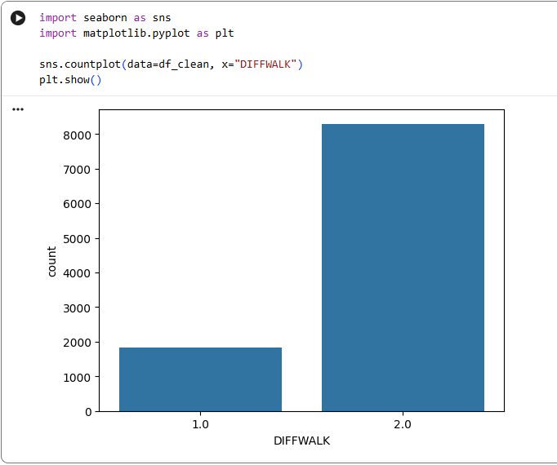
Description
The first visualization is a count plot displaying the distribution of the variable DIFFWALK, which measures whether respondents reported difficulty walking or climbing stairs. In this dataset, a value of 1 indicates that the respondent reported difficulty walking or climbing stairs, while a value of 2 indicates that the respondent did not report difficulty walking or climbing stairs. The x-axis represents the response categories, and the y-axis represents the number of respondents within each category. Count plots are useful for examining the frequency distribution of categorical variables and identifying patterns within a population.

Insights
The visualization reveals a substantial imbalance between the two response categories. Most respondents fall into the category indicating no difficulty walking or climbing stairs, while a smaller portion report experiencing mobility limitations. This finding suggests that although mobility challenges are not present in the majority of respondents, a meaningful segment of the population experiences functional limitations that may increase their risk of falls and reduced independence.

The results demonstrate that mobility limitations affect a notable portion of the sample and therefore represent an important public health concern. Because difficulty walking and climbing stairs are closely associated with fall risk, physical function, and quality of life among older adults, the DIFFWALK variable serves as a meaningful outcome measure for this study. Understanding which factors are associated with mobility limitations may help identify individuals at greater risk for adverse health outcomes.

Data Visualization 2
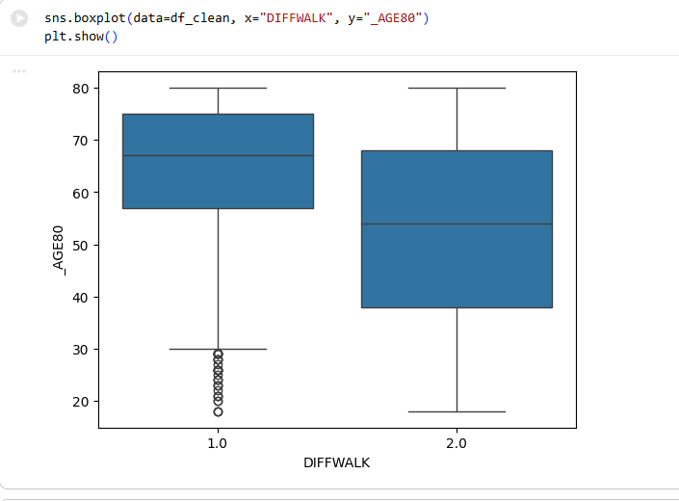.
Description
The second visualization is a boxplot comparing age distributions across the DIFFWALK categories. The x-axis represents the DIFFWALK response groups, while the y-axis represents respondent age. The boxplot displays the median age, interquartile range, overall spread of the data, and potential outliers within each category.
Insights
The boxplot demonstrates a noticeable difference in age distributions between respondents who reported difficulty walking or climbing stairs and those who did not. Individuals reporting mobility limitations have a higher median age and are generally concentrated within older age ranges. This pattern suggests that mobility challenges become more prevalent as people age.
The visualization further indicates that age may be an important predictor of mobility status. While there is some overlap between the groups, respondents reporting difficulty walking tend to be older overall. This finding aligns with existing research showing that aging is associated with declines in muscle strength, balance, and physical function, all of which contribute to increased mobility limitations and fall risk.

Data Visualization 3

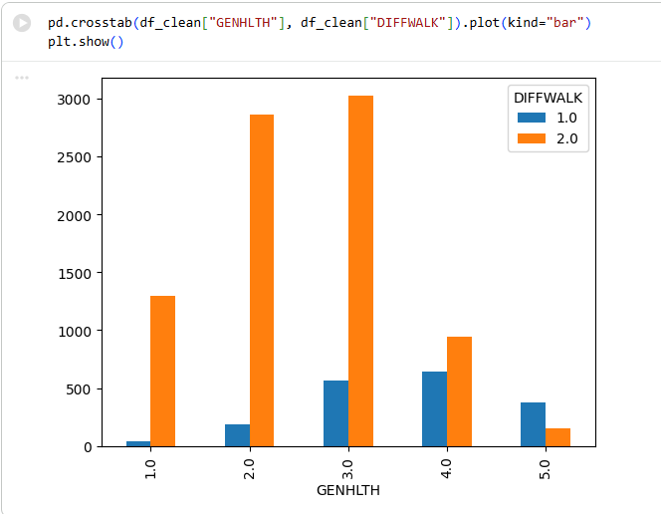
Description
The third visualization is a grouped bar chart illustrating the relationship between self-reported general health (GENHLTH) and mobility limitations (DIFFWALK). The x-axis represents categories of general health, while the y-axis represents the number of respondents. Separate bars within each category indicate the corresponding DIFFWALK responses.

Insights
The grouped bar chart reveals a clear relationship between self-reported general health and mobility status. Respondents reporting fair or poor health are more likely to report difficulty walking or climbing stairs, whereas respondents reporting very good or excellent health are more likely to report no mobility limitations. This pattern suggests that perceived health status is closely linked to functional mobility.

The findings indicate that general health may be a valuable predictor of mobility limitations and fall risk. Individuals who perceive their health as poor may be experiencing chronic conditions, reduced physical functioning, or other health challenges that affect their ability to move safely and independently. As a result, self-reported health status may provide useful information for identifying populations that could benefit from fall-prevention interventions and mobility support programs.

Summary
The three visualizations collectively provide important insights into mobility limitations among adults represented in the BRFSS dataset. The count plot established the distribution of the DIFFWALK variable and confirmed that mobility limitations affect a substantial portion of respondents. The boxplot demonstrated a relationship between age and mobility status, showing that older individuals are more likely to have trouble walking or climbing stairs. Finally, the grouped bar chart illustrated a strong association between self-reported health and mobility limitations. Together, these findings suggest that age and general health are important factors associated with mobility outcomes and may serve as meaningful predictors in future analyses focused on fall risk and healthy aging.

Predictive Models

Predictive Modeling Definitions
Predictive modeling is a machine learning approach that uses historical data to identify patterns and estimate the probability of future outcomes. In healthcare analytics, predictive models are commonly used to identify patients at increased risk for adverse events, allowing organizations to implement preventative interventions and improve clinical decision-making. Common supervised learning techniques include Logistic Regression, Decision Trees, and Random Forests, each of which offers different advantages in terms of interpretability, predictive performance, and handling complex relationships among variables (Omar et al., 2024).

This study compares three supervised machine learning algorithms to predict self-reported mobility difficulty using BRFSS data. Logistic Regression estimates the probability of a binary outcome by modeling the relationship between predictor variables and the target outcome. Decision Trees classify observations through a sequence of decision rules, while Random Forest improves predictive performance by combining multiple decision trees into an ensemble model that reduces overfitting and improves generalization. Comparing multiple algorithms provides a systematic method for selecting the model that offers the strongest predictive performance while maintaining practical interpretability for healthcare applications (Omar et al., 2024).

Predictive Model 1
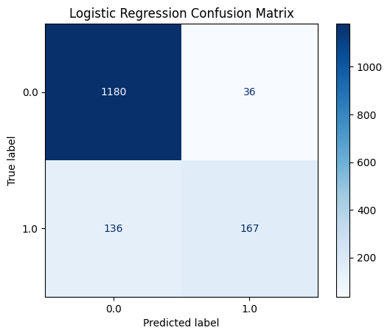

Logistic Regression was selected as the first predictive model because the dependent variable was binary, indicating whether respondents reported difficulty walking or climbing stairs. Prior to model development, missing values were addressed through median imputation for continuous variables and mode imputation for categorical variables. Continuous predictor variables were standardized before training to improve model convergence. The dataset was divided into an 80% training set and a 20% testing set using a stratified sampling approach to preserve the class distribution.

The Logistic Regression model achieved an accuracy of 88.7%, precision of 82.3%, recall of 55.1%, and an F1 score of 0.660. The confusion matrix showed that the model correctly classified 1,180 respondents without mobility difficulty and 167 respondents with mobility difficulty while producing relatively few false positive predictions. Although recall indicates that some positive cases were missed, the model demonstrated the strongest overall balance between precision and recall among the evaluated algorithms, making it the highest-performing model in this analysis.

Predictive Model 2
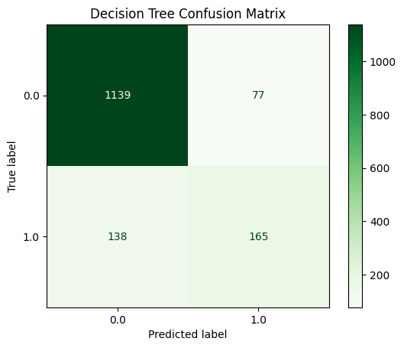
A Decision Tree classifier was developed using the same training and testing datasets to provide an interpretable, rule-based classification model. Decision Trees partition observations into increasingly homogeneous groups by selecting predictor variables that maximize information gain at each split. A maximum tree depth of five was specified to reduce overfitting while maintaining model interpretability.

The Decision Tree achieved an accuracy of 85.8%, precision of 68.2%, recall of 54.5%, and an F1 score of 0.606. While overall performance remained acceptable, the Decision Tree produced lower precision and F1 score than Logistic Regression. The confusion matrix indicated an increase in false positive predictions, suggesting that the model was less effective at distinguishing respondents with and without mobility difficulty. Although Decision Trees are highly interpretable, their predictive performance was weaker than the Logistic Regression model for this dataset.

Predictive Model 3
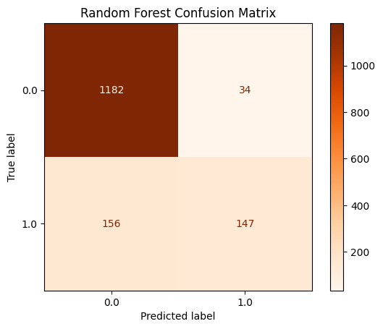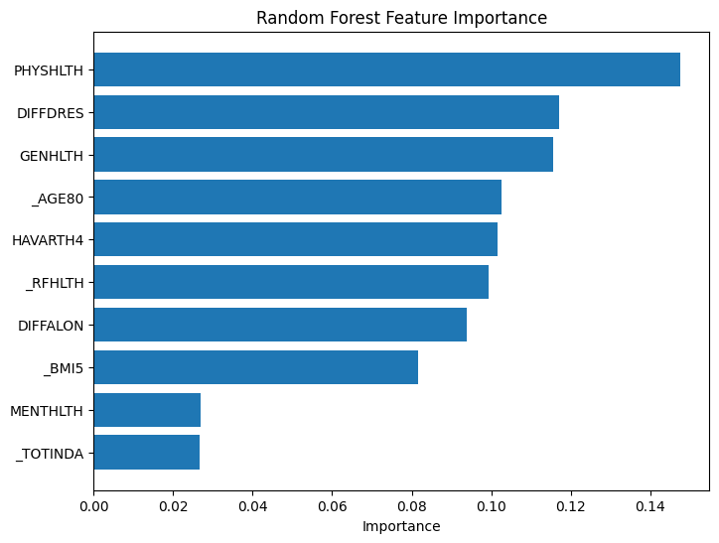

Random Forest was evaluated as an ensemble learning method designed to improve predictive performance by combining the results of multiple Decision Trees. The model was constructed using 100 decision trees with a maximum depth of eight to balance predictive accuracy and computational efficiency. In addition to classification performance, feature importance scores were generated to identify the variables contributing most to model predictions.
The Random Forest model achieved an accuracy of 87.5%, precision of 81.2%, recall of 48.5%, and an F1 score of 0.607. Overall accuracy remained high; however, the model identified fewer respondents with mobility difficulty than Logistic Regression, resulting in the lowest recall among the three algorithms. Feature importance analysis indicated that physical health (PHYSHLTH), difficulty dressing (DIFFDRES), general health (GENHLTH), age (_AGE80), and arthritis (HAVARTH4) were among the strongest predictors of mobility difficulty. These findings are consistent with established risk factors associated with functional decline among older adults.

Model | Accuracy | Precision | Recall | F1 Score
Logistic Regression | 0.887 | 0.823 | 0.551 | 0.660
Decision Tree | 0.858 | 0.682 | 0.545 | 0.606
Random Forest | 0.875 | 0.812 | 0.485 | 0.607

Review of Machine Learning Models
Three supervised machine learning algorithms were evaluated to determine their ability to predict self-reported mobility difficulty using BRFSS health indicators. Logistic Regression produced the strongest overall performance, achieving the highest accuracy (88.7%), precision (82.3%), recall (55.1%), and F1 score (0.660). Although all three models demonstrated acceptable predictive capability, Logistic Regression consistently outperformed both Decision Tree and Random Forest across every evaluation metric.

The Decision Tree provided the greatest interpretability because its classification rules can be easily visualized and explained. However, it demonstrated lower predictive accuracy and precision than the other algorithms. Random Forest improved upon the Decision Tree by reducing overfitting and identifying the most influential predictor variables through feature importance analysis. Despite these advantages, the Random Forest model did not surpass Logistic Regression on this dataset, particularly in recall, where identifying positive mobility difficulty cases is especially important for healthcare screening applications.

Based on the comparative analysis, Logistic Regression was selected as the champion model for this capstone. Its superior balance of accuracy, precision, recall, and F1 score indicates that it provided the most reliable predictions while maintaining strong interpretability. The results suggest that routinely collected health indicators, particularly physical health status, general health, age, arthritis, and functional limitations, can be used effectively to predict mobility difficulty and support early identification of individuals who may benefit from targeted fall prevention interventions.

Final Report

Findings
This project investigated how predictive analytics and machine learning can be used to identify older adults who may be at increased risk for mobility limitations associated with fall risk. Falls remain one of the leading causes of injury, hospitalization, and loss of independence among older adults in the United States. Using the 2024 Behavioral Risk Factor Surveillance System (BRFSS) dataset, this study examined demographic, health, and functional variables associated with serious difficulty walking or climbing stairs (DIFFWALK), which served as a proxy measure for elevated fall risk. Twenty variables related to age, physical health, chronic disease, physical activity, functional limitations, and overall health status were selected for analysis.
The project followed the complete data science process, including data cleaning, exploratory analysis, visualization, feature selection, predictive modeling, and model evaluation. Three supervised machine learning algorithms were developed and compared: Logistic Regression, Decision Tree, and Random Forest. Model performance was evaluated using accuracy, precision, recall, F1-score, and confusion matrices. Logistic Regression produced the strongest overall performance, achieving an accuracy of approximately 88.7% while maintaining the highest balance between precision and recall. Decision Tree and Random Forest models also demonstrated strong predictive ability but produced slightly lower overall performance.
Visualizations demonstrated that respondents reporting mobility limitations were generally older and more likely to report poorer overall health. Feature importance analysis further identified physical health, difficulty dressing, general health, arthritis, age, and body mass index as some of the strongest predictors of mobility limitations. Overall, this project demonstrates that machine learning can successfully identify individuals who may be at greater risk for mobility decline using large public health datasets. These findings may assist healthcare providers, senior living communities, and public health organizations in developing earlier interventions and more effective fall prevention strategies.
.

Review of Ethical Aspects for Your Selected Project
This project relied exclusively on publicly available BRFSS survey data collected by the Centers for Disease Control and Prevention. Because the dataset is fully de-identified before public release, no personally identifiable information was available during analysis. As a result, privacy risks were minimal, and no additional participant consent or institutional review board approval was required for this project.

Although the dataset protects participant privacy, ethical considerations remain important when applying predictive analytics within healthcare. Machine learning models should be used to support clinical decision-making rather than replace professional judgment. Predictive models may identify individuals who appear to be at elevated risk, but healthcare providers should always consider additional clinical information before making treatment recommendations.

Another important ethical consideration involves algorithmic bias. Public health survey data may underrepresent certain populations or contain self-reported responses that introduce measurement error. Because predictive models learn patterns from historical data, these limitations may influence model performance across different demographic groups. Future implementations should continue evaluating fairness, transparency, and model performance to ensure equitable healthcare outcomes.

Review of Success or Completion
Overall, this project successfully achieved its primary objectives. The selected datasets were appropriate for predictive modeling, relevant variables were identified, and multiple machine learning models were successfully developed and evaluated. The project also demonstrated the complete data science workflow from data acquisition through final interpretation of results.

One of the greatest accomplishments was developing predictive models that produced relatively strong classification performance while remaining interpretable. The project also strengthened my understanding of data preprocessing, feature engineering, model evaluation, and healthcare analytics. The experience reinforced the importance of careful data preparation before developing predictive models.

Review of KPIs

The primary key performance indicator (KPI) for this project was the predictive performance of the machine learning models. Model performance was evaluated using accuracy, precision, recall, F1 score, and confusion matrices. These metrics provided a comprehensive assessment of each model's ability to correctly classify respondents reporting mobility limitations. Logistic Regression achieved the strongest overall performance, producing an accuracy of 88.7%, precision of 82.3%, recall of 55.1%, and an F1 score of 0.660. These results indicate that the model successfully balanced overall classification accuracy while maintaining relatively strong identification of individuals experiencing mobility limitations.

A second KPI focused on identifying meaningful predictors of mobility difficulty. The Random Forest feature importance analysis demonstrated that physical health, difficulty dressing, general health, age, arthritis, overall health status, difficulty completing errands alone, and body mass index contributed most strongly to model predictions. These findings align with established clinical knowledge regarding mobility decline and provide confidence that the models captured meaningful relationships within the dataset rather than random statistical patterns.

A final KPI involved successfully completing each stage of the data analytics process. The project included data acquisition, cleaning, preprocessing, exploratory data analysis, visualization, predictive modeling, model comparison, and interpretation of findings. Completing each phase while producing reliable analytical results demonstrates that the project met its overall objectives and provides a repeatable framework for future healthcare analytics projects involving large public health datasets.

Review of Lessons Learned

One of the most valuable lessons learned during this project was the importance of data preparation. Considerable time was devoted to selecting appropriate variables, replacing invalid survey response codes, addressing missing values, and preparing the dataset for predictive modeling. Although these tasks required substantial effort, they greatly improved model reliability and reinforced the understanding that successful machine learning projects depend heavily on data quality.

Another important lesson involved evaluating model performance using multiple metrics rather than relying solely on overall accuracy. Initially, it appeared that all three machine learning models performed similarly. However, comparing precision, recall, F1 score, and confusion matrices demonstrated meaningful differences in their ability to correctly identify respondents with mobility limitations. This experience emphasized that selecting the best predictive model requires evaluating multiple performance measures based on the goals of the analysis rather than a single statistic.

Finally, this project strengthened both my technical and analytical skills. I gained additional experience using Python, Google Colab, pandas, scikit-learn, and data visualization techniques while developing machine learning models from a large healthcare dataset. More importantly, I developed a greater appreciation for how predictive analytics can support evidence-based decision-making within healthcare organizations. As someone who works directly with older adults, this project demonstrated how data analytics can complement clinical expertise by identifying individuals who may benefit from earlier interventions designed to reduce mobility decline and improve quality of life.

Recommendations for Future Analysis
Several opportunities exist to expand this project in future research. First, future studies could incorporate additional healthcare datasets, such as the National Health and Aging Trends Study (NHATS), to examine more detailed measures of mobility, balance, physical activity, and documented fall history. Combining multiple datasets may improve predictive performance while providing a more comprehensive understanding of factors associated with fall risk among older adults.

Future research could evaluate Extreme Gradient Boosting (XGBoost), an ensemble machine learning algorithm that often achieves strong predictive performance by sequentially correcting errors from previous decision trees (Chen & Guestrin, 2016). Comparing XGBoost with Logistic Regression, Decision Tree, and Random Forest may determine whether additional improvements in predictive performance can be achieved.

Overall, this project demonstrates that predictive analytics represents a valuable tool for supporting healthcare decision-making. Continued development of interpretable machine learning models may assist healthcare providers, senior living communities, and public health agencies in identifying individuals at elevated risk for mobility decline and implementing preventative interventions before more serious health outcomes occur.

References
Alias, Z., Zawawi, E. M. A., Yusof, K., & Aris, N. M. (2014). Determining critical success factors of project management practice: A conceptual framework. Procedia - Social and Behavioral Sciences, 153, 61–69. https://doi.org/10.1016/j.sbspro.2014.10.041
Burns, E., & Kakara, R. (2018). Deaths from falls among persons aged ≥65 years—United States, 2007–2016. Morbidity and Mortality Weekly Report, 67(18), 509–514. https://www.cdc.gov/mmwr/volumes/67/wr/mm6718a1.htm
Centers for Disease Control and Prevention. (2024). Behavioral Risk Factor Surveillance System (BRFSS). https://www.cdc.gov/brfss
Centers for Disease Control and Prevention. (2024). Older adult falls: Data and statistics. https://www.cdc.gov/falls/data-research/index.html
Chen, T., & Guestrin, C. (2016). XGBoost: A scalable tree boosting system. Proceedings of the 22nd ACM SIGKDD International Conference on Knowledge Discovery and Data Mining, 785–794. https://doi.org/10.1145/2939672.2939785
Hu, K. (2020). Become competent within one day in generating boxplots and violin plots for a novice without prior R experience. Methods and Protocols, 3(4), Article 64. https://doi.org/10.3390/mps3040064
Jung, H., Lee, S., & Kim, Y. (2025). Multifactorial predictors of falls in older adults using national aging data. BMC Geriatrics, 25, Article 1. https://doi.org/10.1186/s12877-025-06515-2
Kaur, P., Stoltzfus, J., & Yellapu, V. (2018). Descriptive statistics. International Journal of Academic Medicine, 4(1), 60–63. https://journals.lww.com/ijam/fulltext/2018/04010/descriptive_statistics.7.aspx
Li, Q. (2020). Overview of data visualization. In Embedding data intelligence within visual analytics. Springer. https://pmc.ncbi.nlm.nih.gov/articles/PMC7303292/
Ofori, M. A., et al. (2025). Visual communication of public health data: A scoping review. Frontiers in Public Health. https://pmc.ncbi.nlm.nih.gov/articles/PMC12060258/
Omar, E. D., et al. (2024). Comparative analysis of Logistic Regression, Gradient Boosted Trees, Support Vector Machine, and Random Forest models for predicting acute kidney injury after cardiac surgery. International Journal of Nephrology and Renovascular Disease. https://doi.org/10.2147/IJNRD.S466947
Parmenter, D. (2015). Key performance indicators: Developing, implementing, and using winning KPIs (3rd ed.). Wiley.
Rajagopalan, R., Khanna, M., & Patel, V. (2023). Artificial intelligence for falls management in older adult care: A review. Journal of Nursing Management, 1–15. https://onlinelibrary.wiley.com/doi/10.1111/jonm.13853
Santos, D. A., Shiroma, E. J., & Studenski, S. (2021). Machine learning in aging: Developing prediction models for serious fall injury. The Journals of Gerontology: Series A, 76(4), 647–654. https://doi.org/10.1093/gerona/glaa174
Zhang, Y., et al. (2021). Impact of data visualization on decision-making and its implications for public health practice. Journal of Public Health Policy. https://www.tandfonline.com/doi/full/10.1080/17538157.2021.1982949

